.

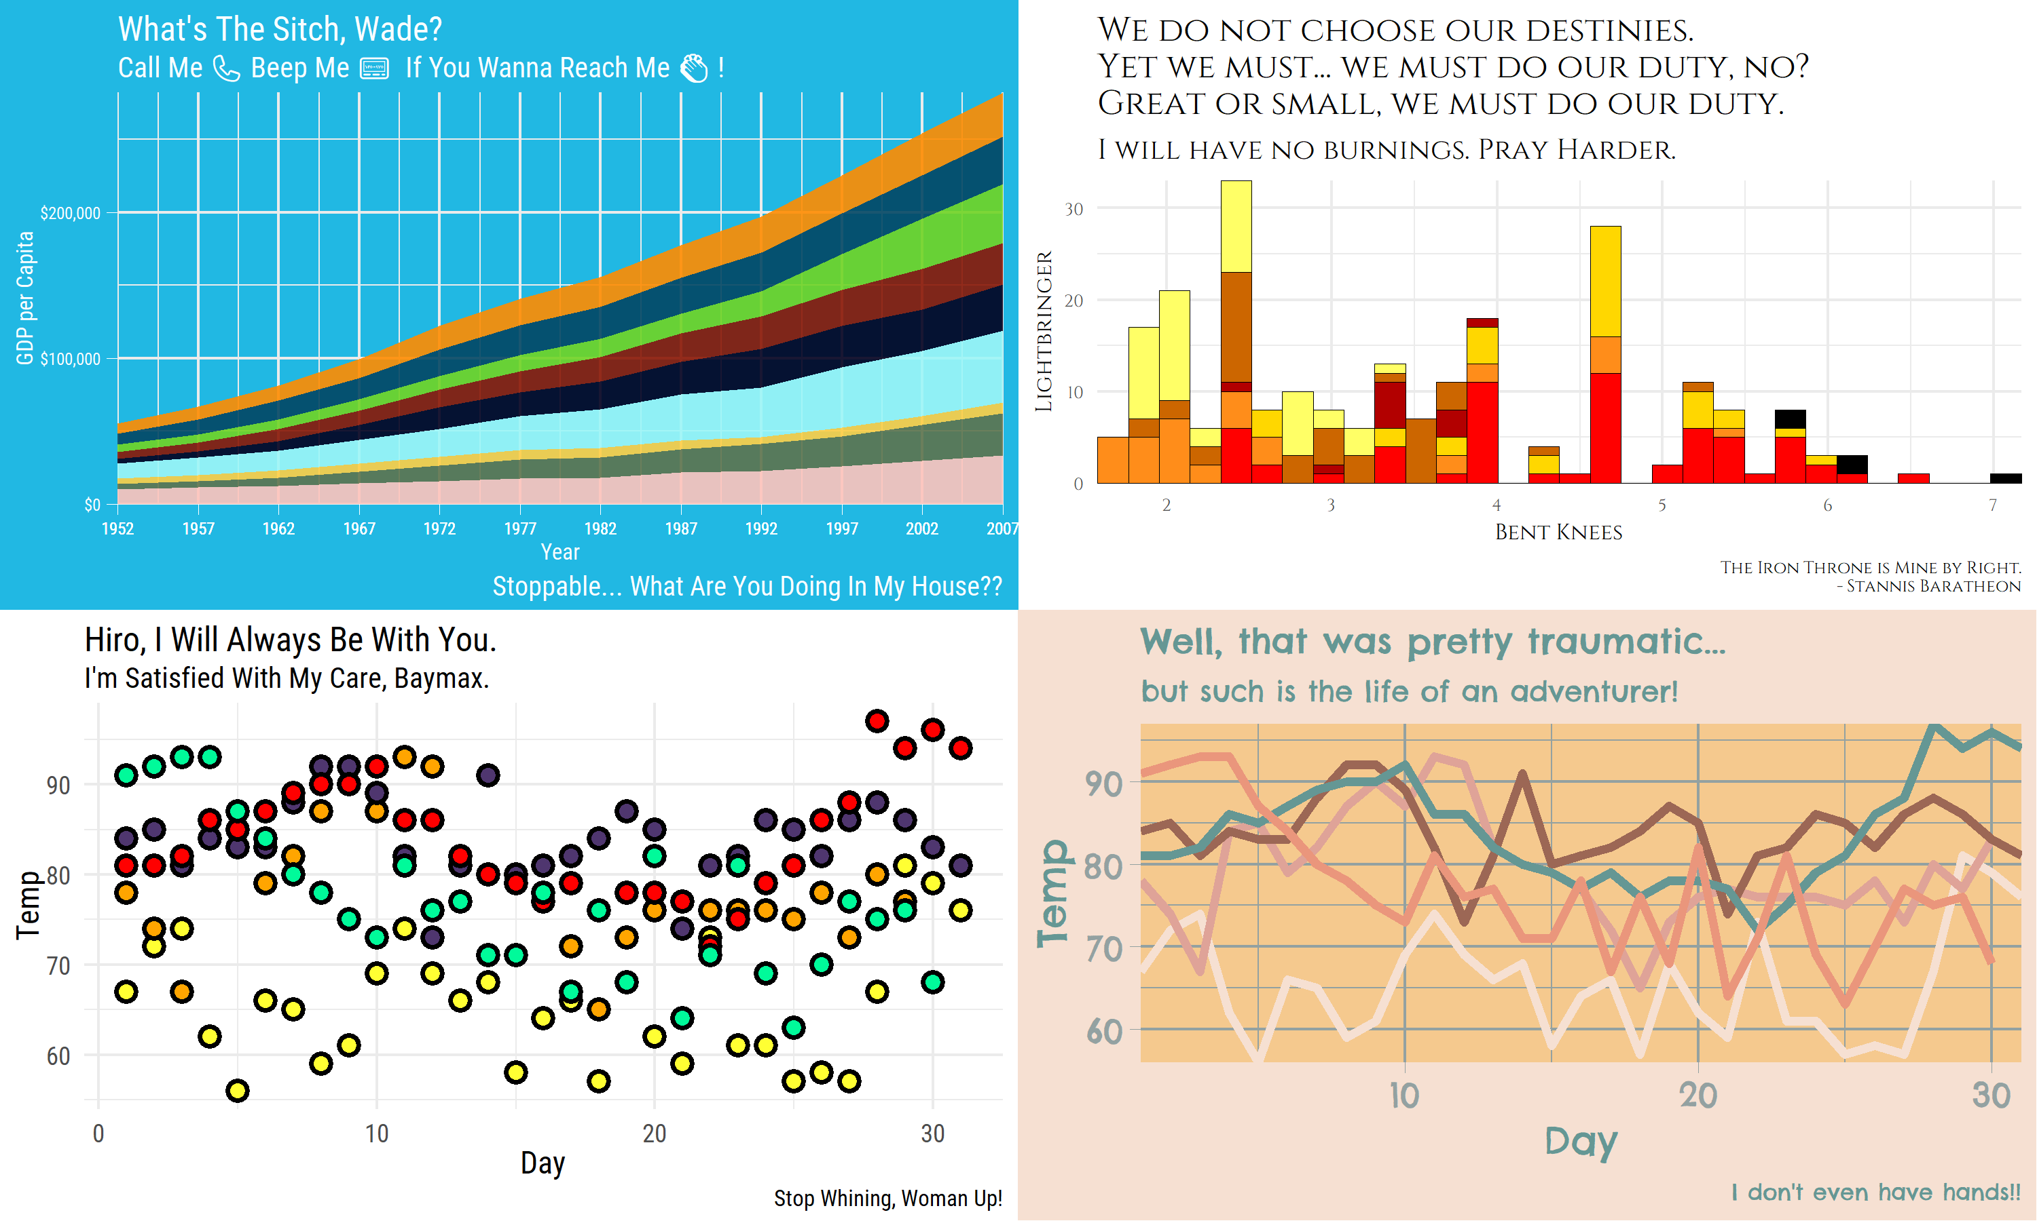

tvthemes v1.0.0 is **finally** on CRAN! After a long summer of  
procrastination, etc. and a couple of back-and-forth submissions with CRAN to fix some  
issues, as of September 3rd you can finally:

install.packages("tvthemes")

library(tvthemes)

My first CRAN package!



| **TV Show** | **Palette(s)** | **Theme(s)** |
| --- | --- | --- |
| [Game of Thrones](https://en.wikipedia.org/wiki/Game_of_Thrones) | Stannis Baratheon, House Martell, House Arryn, House Manderly | NA |
| [Kim Possible](https://en.wikipedia.org/wiki/Kim_Possible) | 1 | NA |
| [Big Hero 6](https://en.wikipedia.org/wiki/Big_Hero_6:_The_Series) | 1 | NA |
| [Hilda](https://en.wikipedia.org/wiki/Hilda_(TV_series)) | Day, Dusk, Night | Day, Dusk, Night |
| [Attack on Titan](https://en.wikipedia.org/wiki/Attack_on_Titan) | 1 | NA |

**The One True King and Some Other Houses**

Let’s start with the new additions to the Palettes of Ice & Fire. When  
I first created the palettes for the great houses of Westeros I  
immediately ran into the problem of there being so many houses that used  
similar color schemes. Namely, the combinations of red, black, and  
yellow/orange used in varying quantities by House Lannister, House  
Targaryen, House Martell, and House Baratheon of Dragonstone. Originally I just ran away from the problem by omitting House Martell and House Baratheon of Dragonstone but I came back to it mainly because I’m a huge Stannis fan. It’s definitely not perfect and there’s still some overlap but I tried to focus more on browns and oranges for Martell while Stannis got more brighter versions of the orange and red colors.

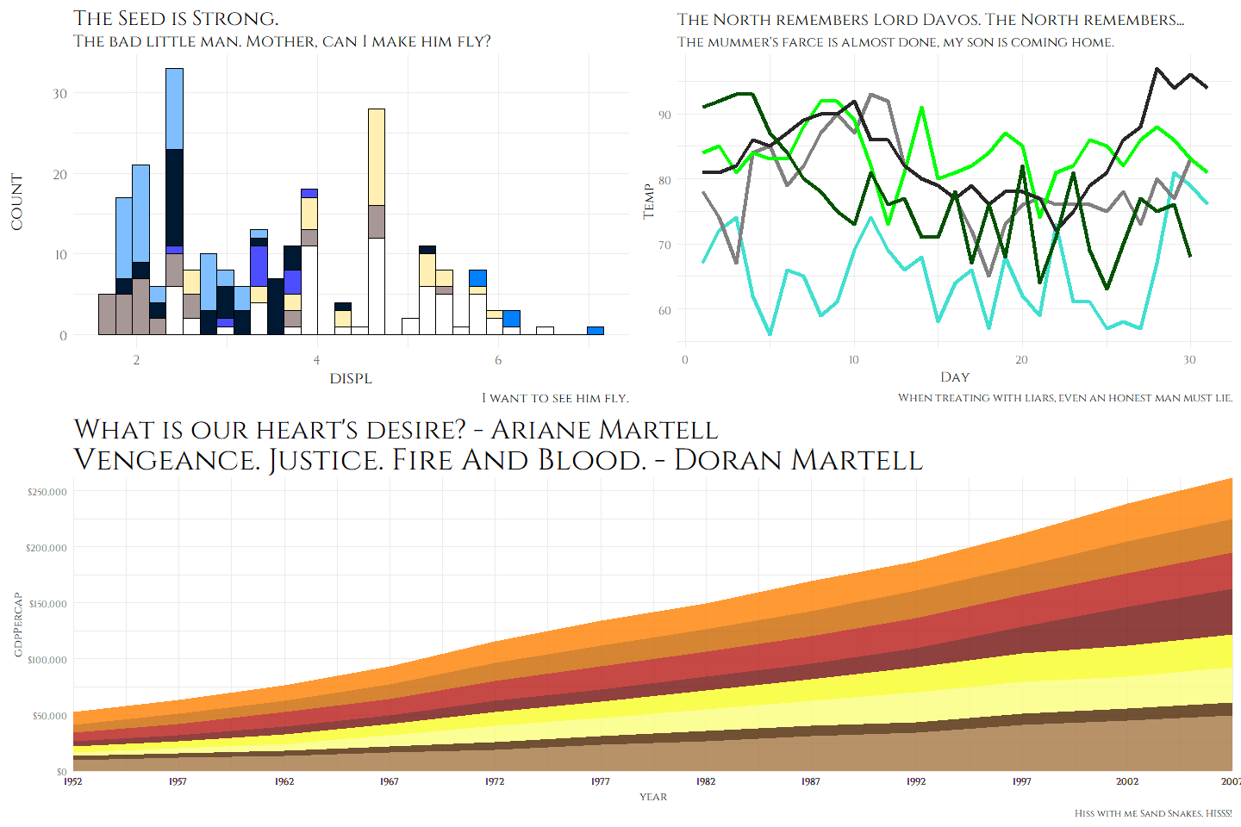

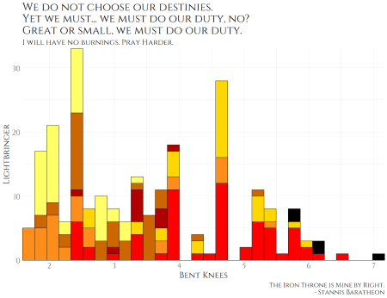

I’m pretty happy with the line-up for the Westerosi houses although I  
may add House Bolton and House Dayne later on. A RGB color-distance tool  
may help in having less problems with similar looking palettes in the  
future. (Stannis: fewer problems…)

**Kim Possible**

This was a really fun one to work on due to the great color/style  
diversity seen across the characters. I’m especially a fan of Shego’s  
lime-green and Doctor Drakken’s midnight-blue/navy-ish colored outfits.  
Paired against Kim’s orange-red hair and khaki cargo pants color with  
Ron’s burgundy jersey and dark blue shirt it makes for a great palette of  
colors!

scales::show_col(tvthemes:::kimPossible_palette)

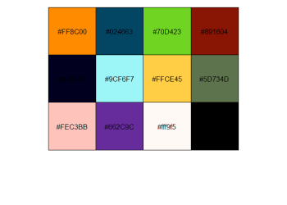

Together with the Spongebob theme it makes for a great looking graph!

## library(ggplot2)

## library(magrittr)

## library(glue)

## library(cowplot)

## library(dplyr)

## library(extrafont)

## loadfonts(quiet = TRUE)

data <- gapminder::gapminder %>%

filter(country %in% c("France", "Germany", "Ireland", "Italy",

"Japan", "Norway", "Belarus", "United Kingdom",

"Peru", "Spain")) %>%

mutate(year = as.Date(paste(year, "-01-01", sep = "", format = '%Y-%b-%d')))

ggplot(data = data, aes(x = year, y = gdpPercap, fill = country)) +

geom_area(alpha = 0.9) +

scale_x_date(expand = c(0, 0),

breaks = data$year,

date_labels = "%Y") +

scale_y_continuous(expand = c(0, 0), labels = scales::dollar) +

scale_fill_kimPossible() +

labs(title = "What's The Sitch, Wade?",

subtitle = glue::glue("Call Me {emo::ji('call')} Beep Me {emo::ji('pager')} If You Wanna Reach Me {emo::ji('clap')} !"),

caption = "Stoppable... What Are You Doing In My House??",

x = "Year", y = "GDP per Capita") +

theme_spongeBob(title.font = "Roboto Condensed",

text.font = "Roboto Condensed",

title.size = 24,

subtitle.size = 20,

text.size = 18,

legend.title.size = 14,

legend.text.size = 12,

ticks = TRUE)

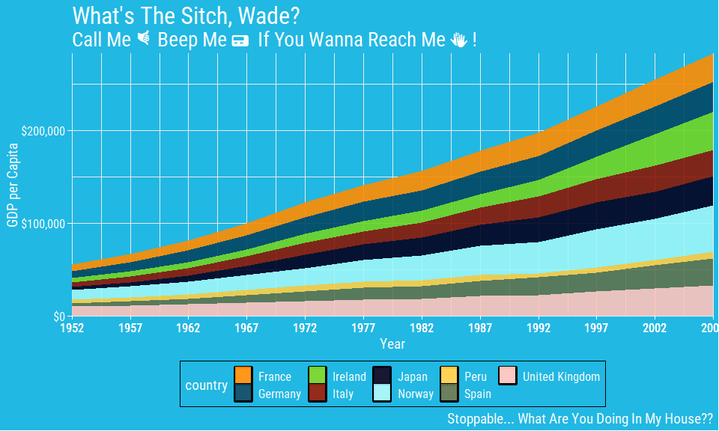

**Hilda**

[Hilda](https://en.wikipedia.org/wiki/Hilda_(TV_series)) is actually a  
TV show that was recommended to me in the comments section of the Reddit  
post of my first tvthemes blog post. You might know the voice actress  
for the main character, Bella Ramsey, who played Lyanna Mormont in Game  
of Thrones. After Googling a few images, I saw how great the color  
scheme was and watched a few episodes.

  
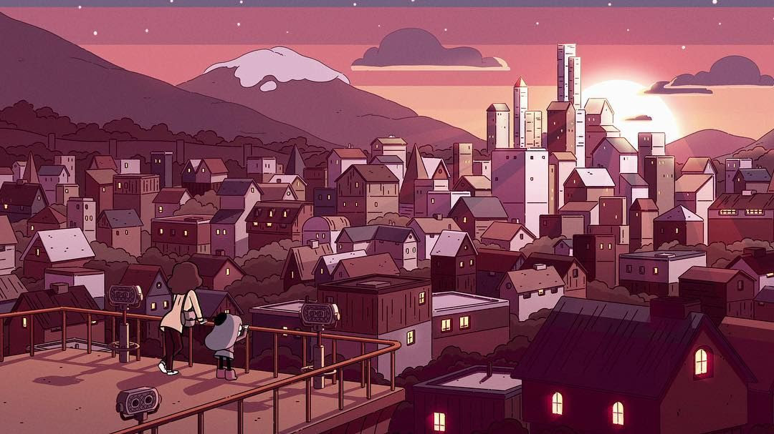  
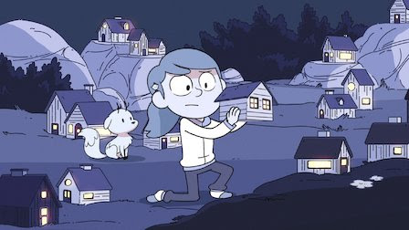

As above, you can see three distinct themes: Day, Dusk, and Night. They  
look fantastic and so I decided to include them for this release!

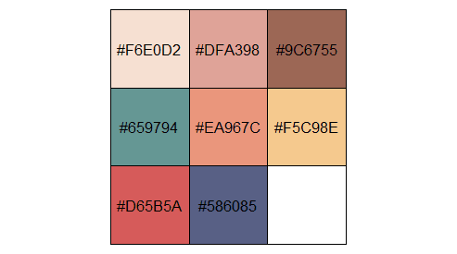  
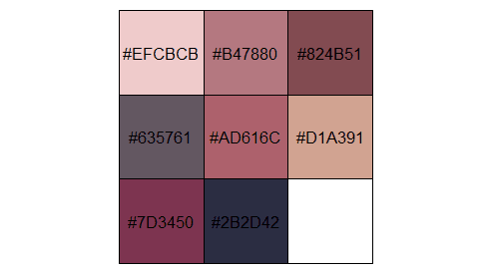  
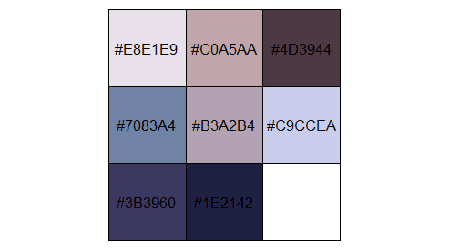

Some example plots:

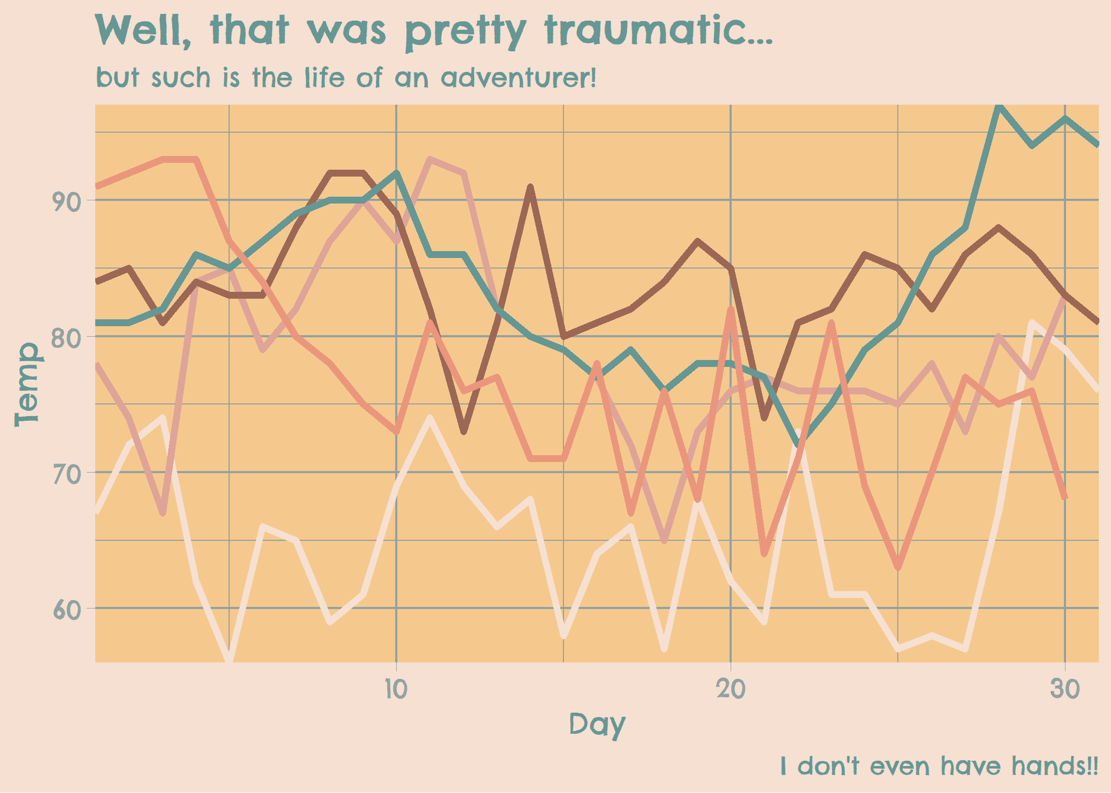  
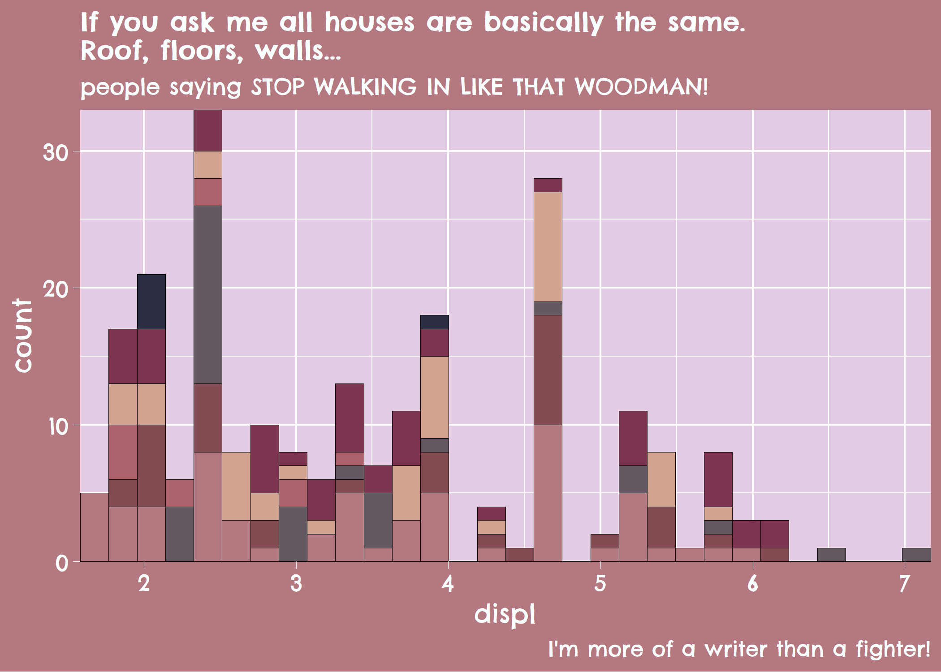  
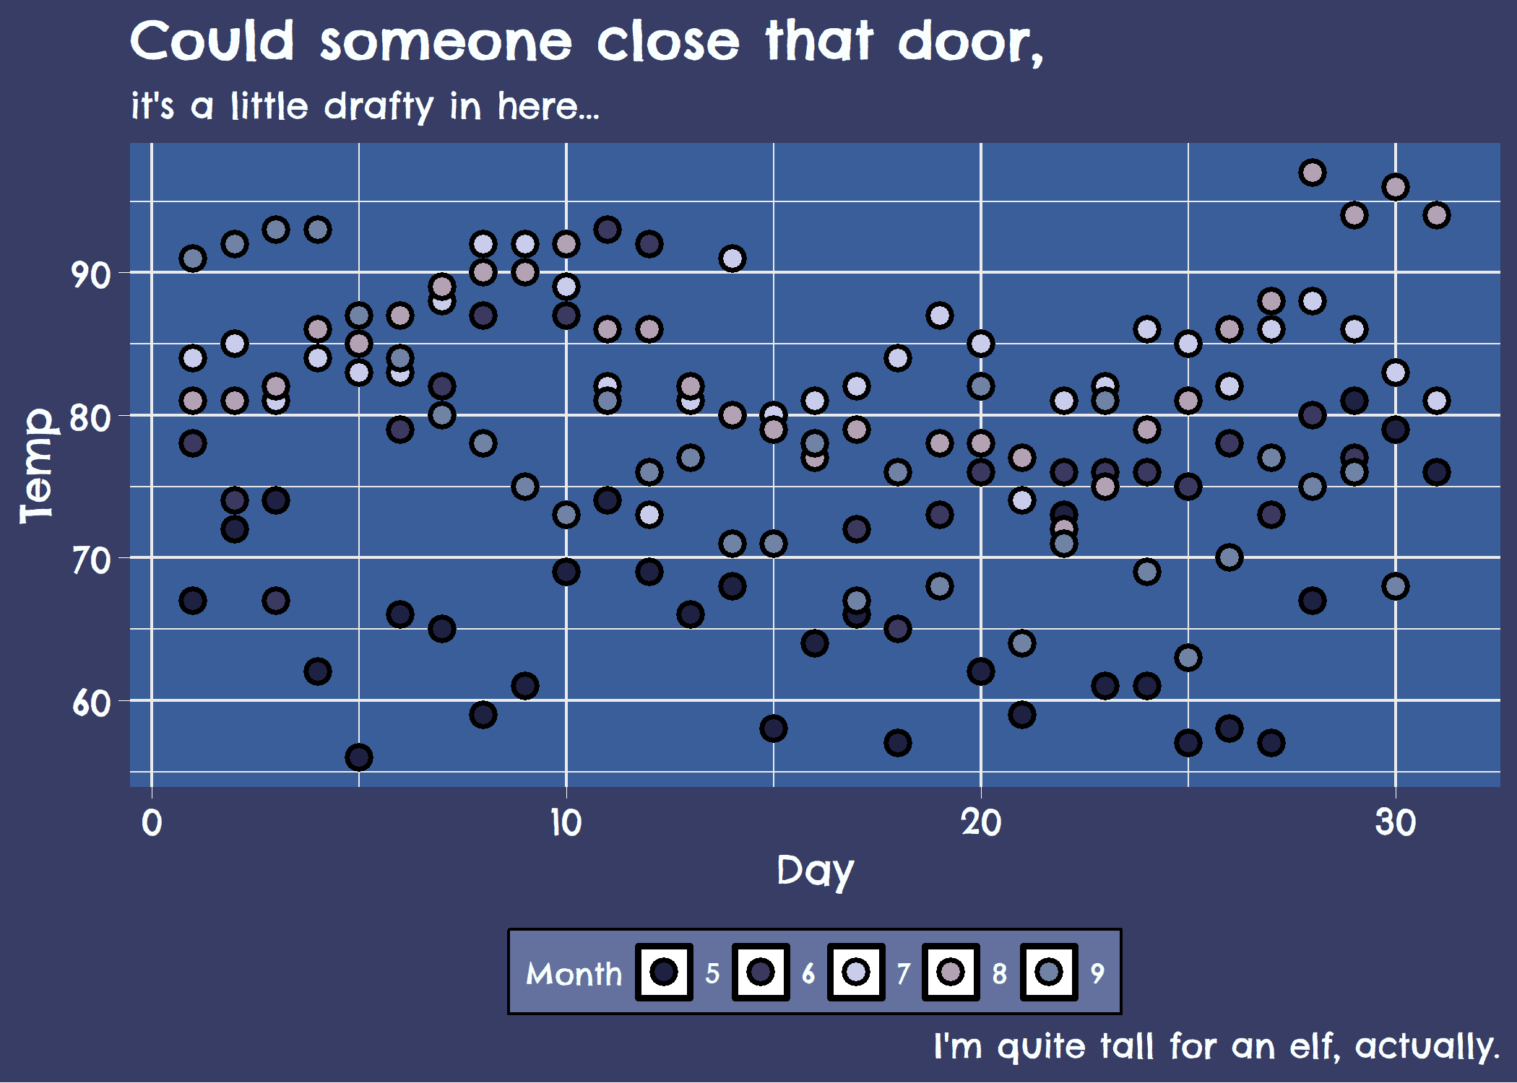

**Big Hero 6**

Most of ya’ll might have seen [the  
movie](https://en.wikipedia.org/wiki/Big_Hero_6_(film)) a couple of  
years ago, but you might not know that they’ve also got an [animated TV  
show](https://en.wikipedia.org/wiki/Big_Hero_6:_The_Series) too! It’s  
more drawn in anime form rather than the 3D form of the movie but it  
still retained its charm, humor, and of course the vivid color scheme  
for our heroes!

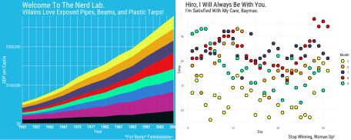

**Attack on Titan**

[Attack on Titan](https://en.wikipedia.org/wiki/Attack_on_Titan) took  
the USA (and the rest of the world) by storm when the first season of  
the anime came out. In light of the subsequent seasons coming out  
recently I decided to create a palette too.

scales::show_col(tvthemes:::attackOnTitan_palette)

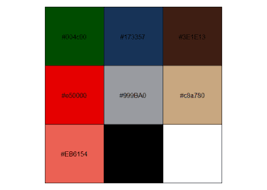

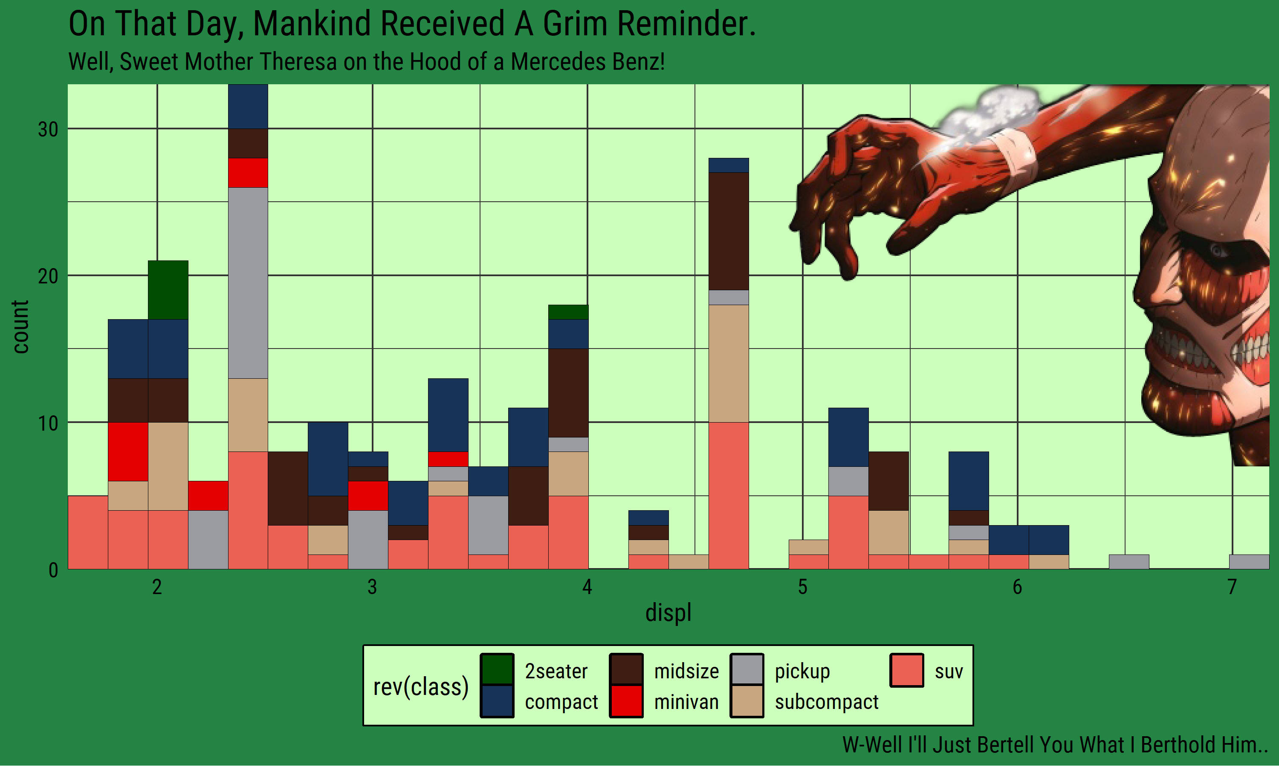

**Code Improvements**

In addition to the new palettes and themes some of the code in  
tvthemes has changed significantly, but don’t worry most of it was  
under the hood with one major exception. In palettes for example, when  
you are calling the palette functions via scale_fill_*() or  
scale_color_*() you now have a lot more options:

* palette: This is the **biggest change** in the code for this  
  release. If multiple palettes are available for a TV show, you can  
  now select the palette: “Stannis”, “FireNation”, “Dusk”, etc. You  
  can leave this blank if only single palette available for a certain  
  TV show. This reduces the amount of functions you have to remember  
  as you only need the one main scale_*() function and then the  
  actual palette from the TV show. You can see some examples below.
* n: Specifies the number of colors. If left blank it defaults to  
  the total number of colors available in the palette.
* type: Specifies whether you want the palette to be “Discrete” or  
  “Continuous”. **NOTE**: Most palettes are only optimized for  
  “Discrete” at the present time so the “Continuous” option isn’t  
  available.
* reverse: Specifies (TRUE/FALSE) whether to reverse the order  
  of colors.

For TV shows with multiple palettes they are now organized under a  
single “palette list” from which you pass the specific palette that you  
want. If you want to check out the colors for these specific palettes:

## Previously:

scales::show_col(tvthemes:::lannister_palette)

scales::show_col(tvthemes:::brooklyn99_dark_palette)

## Now:

scales::show_col(tvthemes:::westeros_palette$Lannister)

scales::show_col(tvthemes:::brooklyn99_palette$Dark)

The specific palettes (fill/color) that changed are:

* **Brooklyn Nine-Nine**: scale_color_brooklyn99(); Default =  
  “Regular”, “Dark”
* **Avatar: The Last Airbender**: scale_color_avatarTLA(); Default  
  = “FireNation”, “EarthKingdom”, “WaterTribe”, “AirNation”
* **Hilda**: scale_fill_hilda(); Default = “Day”, “Dusk”, “Night”
* **Game of Thrones/A Song of Ice & Fire**: scale_color_westeros();  
  Default = “Stark”, “Stannis”, “Tyrell”, “Lannister”, “Manderly”,  
  “Martell”, “Arryn”, “Greyjoy”, “Targaryen”, “Tully”

Some example code:

mannis <- ggplot(mpg, aes(displ)) +

geom_histogram(aes(fill = class), col = "black", size = 0.1) +

scale_fill_westeros(palette = "Stannis", n = 7, reverse = TRUE) +

theme_minimal()

yue <- ggplot(mpg, aes(x = displ, y = cty, color = class)) +

geom_point(size = 3) +

scale_color_avatarTLA(palette = "WaterTribe", n = 7, reverse = TRUE) +

theme_spongeBob()

library(patchwork)

mannis + yue

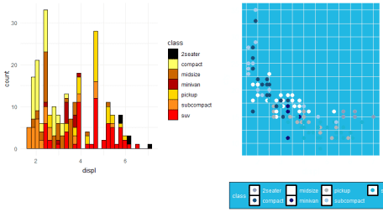

For themes the one change is a toggle option for axis ticks via ticks  
which you can set to either TRUE and the default FALSE.

mpg %>%

ggplot(aes(displ)) +

geom_histogram(aes(fill = class), col = "black", size = 0.1) +

scale_fill_kimPossible(n = 5, reverse = FALSE) +

theme_hildaDay(ticks = TRUE)

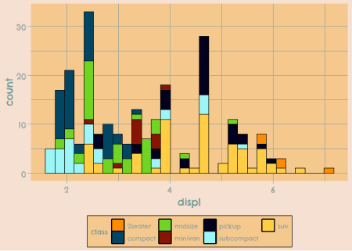

**CRAN Trial(s) and Error(s) and Future Releases**

I tried to emulate him using  
usethis::use_release() but unfortunately it didn’t work as I don’t  
think I had the gh::gh() credentials set up properly. Instead, I just  
followed along Jim’s video as he checked items off on the Github issue  
on his screen.

A problem I came up against initially was that I was using the {emo} and  
{patchwork} packages in the example plots for the README and as you  
might know, having packages via “remotes”/GitHub aren’t allowed as  
dependencies for CRAN packages. So the workaround I had to do was keep  
the code but **not** evaluate it (eval=FALSE in the RMD chunk) and add  
imgur links for the plots so I could delete the packages from the  
“Suggests” section in the DESCRIPTION.

Some other silly CRAN mistakes that I made:

* The title in DESCRIPTION wasn’t in title case
* Not wrapping names of packages/software/API names with ‘single  
  quotes’
* Using fully specified URL when including HTML links

The ‘fully specified URL’ thing took me a while to figure out as I  
included a lot of links throughout the README and it was hard to find  
where a / was needed!

I screwed up and had to resubmit quite a number of times but I think  
it’s important to document failures and the bumps along the road as  
well. Also, I did add a few more tests but as you can see from the  
codecov badge there wasn’t much added in terms of breadth but more in  
terms of depth!

In terms of function names you’ve all seen by now that they follow the  
camelCase style after the initial theme_ and scale_*_. However I  
realized that not all the functions follow this styling which is …  
rather embarrassing on my part. The prime culprits are all the  
import_font_*() functions although I make the excuse that they started  
off as imports of {hrbrthemes}’s font functions and grew out from there.  
However, one egregious mishap happened with theme_parksAndRec_light()  
which really should be theme_parksAndRecLight() instead. As a  
solution, the former is now deprecated (via a .Deprecated() call) in  
favor of the latter; the original _light() version will be deleted in  
the next major release, v2.0.0.

This mistake had me really thinking hard about the naming conventions  
used throughout the package and I will have to make some hard decisions  
concerning whether to keep certain names or even do away with camelCase  
for the next major release. For example, I have been thinking about  
changing theme_theLastAirbender() to theme_avatar() or something a  
lot shorter and memorable. My original intention was to use ‘Avatar’  
more prominently in the names but well… for most people that evokes the  
3D blue aliens from a certain James Cameron film… One thing I am more  
sure about is changing scale_*_avatarTLA() to  
scale_*_lastAirbender() as the current one just seems wonky to type.  
Ultimately the solution might just be to rename both to use  
_lastAirbender() instead!

Don’t worry though as these changes (if any) won’t be fully implemented  
until the next big version change and I will make sure to deprecate the  
old functions in the minor releases leading up to v2.0.0!